**NAXT Quick tips**

**Quick links**

If there are links to reports or websites you regularly use, you can add them to the Quick links list in the NAXT role centre (to the right of the cues).

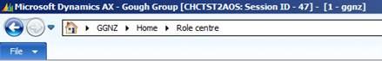

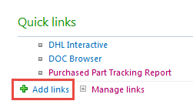

To add a link, click Add links, paste in the hyper link and type in a name for the link. Click ok.

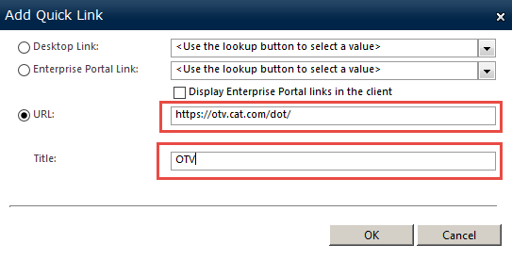

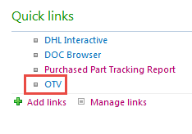

Click on the link name and the website / report will open.

NOTE: These links will be held for you even if a system refresh removes your personalisation.